雷云霆 简历
联系方式
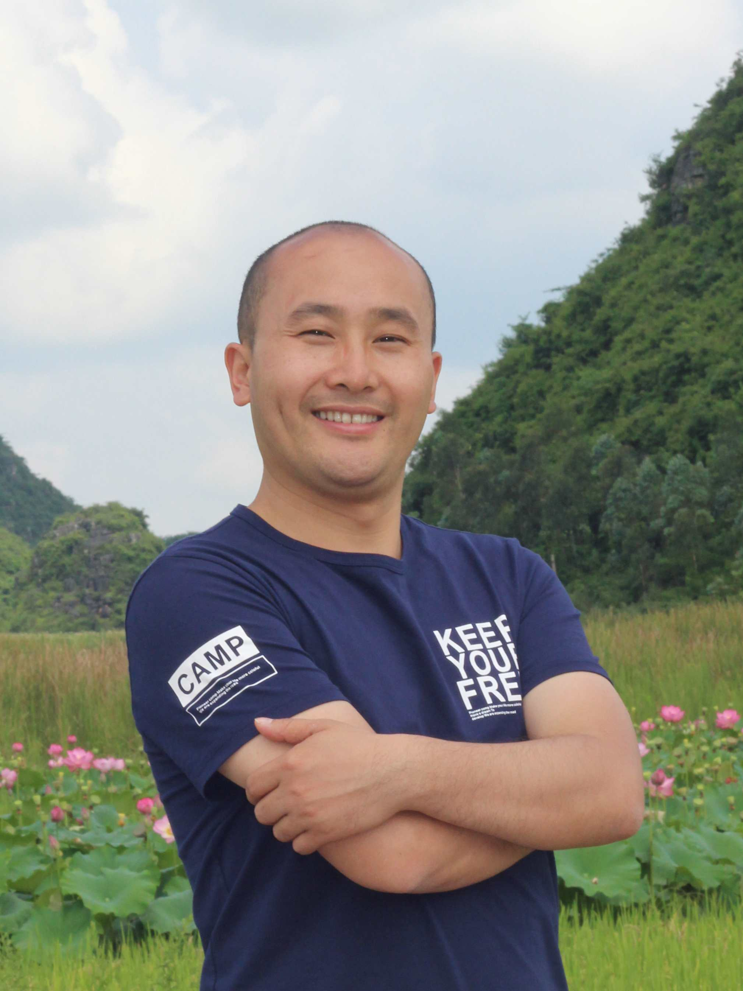
姓名: 雷云霆
地址: 中国科学院昆明植物研究所
云南省昆明市盘龙区蓝黑路132号
邮编：650201
Email: leiyunting@mail.kib.ac.cn

研究方向
植物激素独脚金内酯的抗虫分子机理
菌异养植物与真菌的相互作用

学习经历
2013.09-2017.12 | 植物学，博士 | 四川大学  导师：林宏辉教授
2009.09-2012.06 | 植物学，硕士 | 中国科学院西北高原生物研究所  导师：窦全文研究员
1991.09-1995.07 | 生物工程，学士 | 黑龙江大学

工作经历
2018.01-至今 中国科学院昆明植物研究所，博士后（合作导师: 吴建强研究员）
2012.07-2013.08 中国科学院西北高原生物研究所 研究助理

发表文章 (* 通信作者; # 共同第一作者)
- Cuiping Zhang, Yunting Lei, Chengkai Lu, Lei Wang*, Jianqiang Wu*, MYC2, MYC3, and MYC4 function additively in wounding-induced jasmonic acid biosynthesis and catabolism, Journal of Integrative Plant Biology, 2020. DOI: 10.1111/jipb.12902 （IF_{5 year} = 4.061, Top 15）
- Yunting Lei#, Yuxing Xu#, Christian Hettenhausen, Chengkai Lu, Guojing Shen, Cuiping Zhang, Jing Li, Juan Song, Honghui Lin*, Jianqiang Wu*. Comparative analysis of alfalfa (Medicago sativa L.) leaf transcriptomes reveals genotype-specific salt tolerance mechanisms. BMC Plant Biology, 2018, 18(1):35. （IF_{5 year} = 4.311, Top 15）
- Chengkai Lu, Jinfeng Qi, Christian Hettenhausen, Yunting Lei, Jingxiong Zhang, Mou Zhang, Cuiping Zhang, Juan Song, Jing Li, Guoyan Cao, Saif ul Malook, Jianqiang Wu*. Elevated CO₂ differentially affects tobacco and rice defense against lepidopteran larvae via the jasmonic acid signaling pathway. Journal of Integrative Plant Biology, 2018, 60(5):412-431. （IF_{5 year} = 4.061, Top 15）
- Yunting Lei, Qing Liu, Christian Hettenhausen, Guoyan Cao, Qing Tan, Weiye Zhao, Honghui Lin*, Jianqiang Wu*. Salt-tolerant and -sensitive alfalfa (Medicago sativa) cultivars have large variations in defense responses to the lepidopteran insect Spodoptera litura under normal and salt stress condition. PLOS ONE, 2017, 12(7): e0181589. （IF_{5 year} = 3.337）
- Christian Hettenhausena#, Juan Li#, Huifu Zhuang, Huanhuan Sun, Yuxing Xu, Jinfeng Qi, Jingxiong Zhang, Yunting Lei, Yan Qin, Guiling Sun, Lei Wang, Ian T. Baldwin, and Jianqiang Wu*. Stem parasitic plant Cuscuta australis (dodder) transfers herbivory-induced signals among plants. Proc Natl Acad Sci U S A, 2017, 114(32):E6703-E6709. （IF₅ = 10.600, Top 15）
- 雷云霆，赵闫闫, 喻凤, 李媛, 窦全文*. 利用基因组SSR分子标记对老芒麦品种(种质)鉴别和品种纯度鉴定. 草地学报，2015, 23, 1: 151-155.
- Yunting Lei, Yanyan Zhao, Feng Yu, Yuan Li, Quanwen Dou*. Development and characterization of 53 polymorphic genomic-SSR markers in Siberian wildrye (Elymus sibiricus L.). Conserv Genet Resour, 2014, 6(4):861-864. （IF₅ = 0.963）
- Feng Yu, Yunting Lei, Yuan Li, Quanwen Dou*, Haiqing Wang, Zhiguo Chen. Cloning and characterization of chromosomal markers in alfalfa (Medicago sativa L.). Theoretical and Applied Genetics, 2013, 126(7):1885-1896. （IF_{5 year} = 3.759, Top 5）
- Quanwen Dou*, Yunting Lei, Xiaomei Li, Ivan W. Mott, Richard R.C.Wang. Characterization of alien chromosomes in backcross derivatives of Triticum aestivum×Elymus rectisetus hybrids by using molecular markers and sequential multicolor FISH/GISH. Genome, 2012, 55(5): 337-347. （IF_{5 year} = 1.991）
- Deyong Zhao*, Lei Wang, Yunting Lei. Correlation among SDS sedimentation value, swelling index of glutenin and solvent retention capacity of Spring Wheat. Notulae Scientia Biologicae, 2012, 4(2):132-135.
- 雷云霆, 窦全文*. 青藏高原老芒麦和垂穗披碱草SSR分子标记鉴别. 草业科学, 2012, 29(6): 937-942.
- 窦全文*, 雷云霆, 王海庆. 黄花苜蓿和紫花苜蓿分子核型比较. 草地学报, 2012, 20(4): 718-723.
- 窦全文*, 雷云霆, 王海庆. 苜蓿种质间染色体多态性的荧光原位杂交检测. 植物遗传资源学报, 2012, 13(5): 782-788.

基金与项目
- 2019.04-2020.12，云南省2018年博士后定向培养资助（项目编号：Y934284），“狗尾草CRISPR/Cas9系统的建立及突变体库的制备” ，16.00万元
- 2019.04-2020.12，云南省博士后研究项目（项目编号：Y934385），“狗尾草CRISPR/Cas9基因编辑系统的建立”，2.00万元

