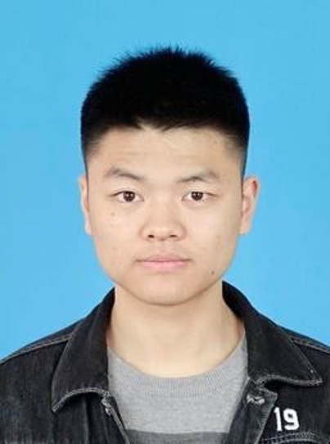**粟忠祥 简历**

**联系方式**

**姓名:** 粟忠祥

**Email:** 1210992184@qq.com

**研究方向**

菌异养植物与真菌的相互作用

**工作经历**

|  |  |  |
| --- | --- | --- |
| 2022.07-至今 | **研究助理** | 中国科学院昆明植物研究所 |

**学习经历**

|  |  |  |
| --- | --- | --- |
| 2009.09-2012.06 | **硕士，生物工程** | 中国科学院昆明植物研究所  导师：吴建强 研究员 |
| 20015.09-2019.07 | **生物工程，学士** | 湖北民族大学科技学院 |

**科研技能**

**生物化学与分子生物学**

1. 植物及真菌总RNA、全基因组DNA提取、普通PCR、反转录PCR、实时荧光定量PCR、引物设计、分子克隆、western blot等基础生物化学与分子生物学实验技术。
2. 真菌原生质体制备、农杆菌介导的真菌遗传转化以及PEG介导的真菌原生质体转化。

**科研成果**

1. **Zhongxiang Su**, Hongjing Li, Yuxing Xu, Cuiping Zhang, Jianqiang Wu*, **Yunting Lei**\*. Establishment of an efficient *Agrobacterium tumefaciens*-mediated transformation system for an *Armillaria* species, a host of the fully mycoheterotrophic plant *Gastrodia elata*. **Folia Microbiologica**, 2024 (accepted). (IF5-year = 2.5)
2. *Z*hao, M., Zheng, X., **Su, Z**., Shen, G., Xu, Y., Feng, Z., Li, W., Zhang, S., Cao, G., Zhang, J.*, Wu, J.* MicroRNA399s and strigolactones mediate systemic phosphate signaling between dodder-connected host plants and control the association of host plants with rhizosphere microbes. New Phytologist, 2024 (in press)
3. 李宏敬, 李锡琴, **粟忠祥**, 仇全雷, 雷云霆. 一株小菇属天麻萌发菌原生质体的制备、再生和应用. **陕西科技大学学报**, 2024 (接收).
4. 袁炎, **粟忠祥**, 许宇星, 李宏敬, 仇全雷, 徐波, 雷云霆*. 基于全基因组重测序的天麻多态性分子标记开发及特征分析, **分子植物育种**, 2023: 1-11. <https://kns.cnki.net/kcms/detail/46.1068.S.20230506.1033.010.html>
5. Yuxing Xu#, Yunting Lei#, **Zhongxiang Su**, Man Zhao, Jinxiong Zhang, Guojing Shen, Lei Wang, Jing Li, Jingfeng Qi, Jianqiang Wu*. A chromosome-scale *Gastrodia elata* genome and large-scale comparative genomic analysis indicate convergent evolution by gene loss in mycoheterotrophic and parasitic plants. **Plant Journal**, 2021, 108(6): 1609-1623. (IF5-year = 7.9, Web of Science数据库引用43次) <https://www.ncbi.nlm.nih.gov/pubmed/34647389>